PENETRATION TESTING REPORT
FOOTPRINTING & NETWORK SCANNING PHASES

Item | Details
Project | W2-PM-FINAL | CYBERSECURITY | NETWORKWALKS
Pentester Name | Maxwell Anaaba Apuswini
Program/Batch | B082-Networkwalks
Date | 21 August 2026
Modules Completed | W2-PM1 (Multiple Kali Linux Tools)  W2-PM5 (Zenmap Scanning)
Client/Target | 1. networkwalks.com (authorized educational practical)  2. My own local network
Permission Secured | Yes (within the authorized training scope and on my own network)
Phases Covered | Phase 1: Reconnaissance & Footprinting  Phase 2: Scanning & Network Discovery

1. Liability Disclaimer
The activities documented in this report were performed strictly for educational purposes and within an authorized scope. The footprinting and reconnaissance activities were completed as part of the Networkwalks cybersecurity practical, while the network scanning activity was performed on my own local network. The tools and techniques discussed in this report should only be used against systems, applications, domains, and networks where appropriate authorization has been granted. Unauthorized reconnaissance, scanning, enumeration, or other security testing may violate organizational policies and applicable laws.

2. Introduction
This report documents the practical activities completed during Week 2 of my Cybersecurity and Ethical Hacking training at Networkwalks. The report covers two major cybersecurity activities: W2-PM1, Footprinting and Reconnaissance using multiple Kali Linux tools, and W2-PM5, Network Scanning and Host Discovery using Zenmap/Nmap.
The first module focused on gathering publicly available information about the target domain, networkwalks.com. Multiple reconnaissance tools were used to investigate domain registration information, web technologies, DNS information, HTTP response headers, Web Application Firewall protection, and DNS records.
The second module focused on network discovery. Using Zenmap and Nmap, I identified my local subnet and performed a Ping Scan to discover active hosts on the network. The scan identified live hosts, IP addresses, available MAC addresses, and network topology information.
Together, these activities demonstrate two important early stages of cybersecurity assessment: gathering information about a target and identifying systems that are present on a network. All practical activities were documented using command outputs, screenshots, observations, and technical findings.

3. Tools Used
Tool | Purpose
Kali Linux | Operating system used for reconnaissance activities
WHOIS | Obtaining publicly available domain registration information
WhatWeb | Web technology fingerprinting
Nslookup | DNS and IP address resolution
curl -I | HTTP response header analysis
WAFW00F | Web Application Firewall detection
DNSRecon | DNS record enumeration
Zenmap | Graphical interface used for network scanning and visualization
Nmap | Network discovery and host scanning
Windows Command Prompt / ipconfig | Local network configuration identification

4. Activities Performed

4.1 Footprinting and Reconnaissance
The first practical module focused on footprinting and reconnaissance. Reconnaissance is an information-gathering phase in cybersecurity where publicly available and technically exposed information about a target can be collected and analyzed. For this activity, I used six tools in Kali Linux to investigate different aspects of the target domain, networkwalks.com.

4.1.1 WHOIS Enumeration
Objective: Query publicly available domain registration information and identify available registration details and name servers.
Command Used:
whois networkwalks.com
The WHOIS utility was used to retrieve publicly available registration-related information about the networkwalks.com domain. The exercise focused on available domain information and the domain's name servers. This demonstrated how publicly exposed domain information can contribute to reconnaissance.

4.1.2 Web Technology Fingerprinting
Objective: Identify technologies and software components associated with the target website.
Command Used:
whatweb networkwalks.com
WhatWeb was used to fingerprint technologies exposed by the target website. The activity focused on identifying web technologies, servers, CMS platforms, frameworks, plugins, and other components that may be publicly exposed. Technology fingerprinting can provide useful context during reconnaissance.

4.1.3 DNS Resolution
Objective: Resolve the target domain name using DNS and identify associated network information.
Command Used:
nslookup networkwalks.com
Nslookup was used to query DNS information and determine how the target domain resolves within DNS infrastructure. DNS resolution provides useful information about publicly exposed infrastructure associated with a domain.

4.1.4 HTTP Header Analysis
Objective: Inspect the HTTP response headers returned by the target website.
Command Used:
curl -I https://networkwalks.com
The curl -I command was used to retrieve and inspect HTTP response headers without downloading the complete webpage. The activity examined information contained in HTTP responses, including server information, headers, redirects, cookies, and other HTTP metadata where available.

4.1.5 Web Application Firewall Detection
Objective: Determine whether a Web Application Firewall is protecting the target website.
Command Used:
wafw00f networkwalks.com
WAFW00F was used to detect whether defensive web application technologies were present in front of the target website. The exercise demonstrated how security professionals can identify defensive technologies that may be deployed to protect web applications.

4.1.6 DNS Enumeration
Objective: Enumerate DNS records associated with the target domain.
Command Used:
dnsrecon -d networkwalks.com
DNSRecon was used to gather information about DNS records associated with the target domain. The activity focused on information such as name servers, mail-related records, TXT/SPF records, and other available DNS information.

4.2 Network Scanning with Zenmap
The second practical module focused on network scanning and host discovery using Zenmap. Zenmap is the graphical interface for Nmap and provides an environment for performing network scans and visualizing scan results. The objectives were to identify the local network subnet, perform host discovery, identify live hosts, record IP addresses, identify available MAC addresses, and visualize network topology.

4.2.1 Local Network Identification
The target subnet used for the practical was:
10.149.61.0/24
The scan configuration used a Ping Scan with the following command:
nmap -sn 10.149.61.0/24

4.2.2 Live Host Discovery
The Nmap Ping Scan examined the selected subnet and reported:
Nmap done: 256 IP addresses (3 hosts up) scanned in 6.27 seconds
Therefore, 3 active hosts were detected within the scanned 10.149.61.0/24 subnet.
[Insert Evidence Screenshot: Zmap1.png]
Figure 7: Zenmap Ping Scan and Live Host Discovery

4.2.3 Number of Live Hosts
Number | IP Address | Status
1 | 10.149.61.18 | Up
2 | 10.149.61.187 | Up
3 | 10.149.61.249 | Up

4.2.4 IP Address Identification
The IP addresses identified during the Ping Scan were:
10.149.61.18
10.149.61.187
10.149.61.249

4.2.5 MAC Address Identification
MAC address information was available for two of the discovered hosts.
IP Address | MAC Address | Vendor
10.149.61.187 | 9C:29:76:E3:ED:B0 | Intel Corporate
10.149.61.249 | 92:B3:5E:E2:98:39 | Unknown
10.149.61.18 | Not displayed in captured output | —

No MAC address was assumed for 10.149.61.18 because it was not displayed in the captured scan result.

4.2.6 Network Topology
Zenmap's topology visualization was used to view the discovered network structure. The topology view displayed network nodes identified during the scanning process. The visualization also displayed 192.168.56.1 as a network node or interface visible in the topology.

5. Risk Analysis / Impact
The activities performed during this practical focused mainly on information gathering and network discovery. The observations below should not be considered confirmed vulnerabilities. Further authorized testing would be required to determine whether any identified system or technology contains an exploitable weakness.
# | Risk / Finding | Evidence / Observation | Potential Impact | Risk Level
1 | Web technology information exposed | WhatWeb identified technologies associated with the website | May assist technology fingerprinting and further security assessment | Medium
2 | Domain and DNS information publicly available | WHOIS, Nslookup and DNSRecon returned available information | Can help build a profile of the target infrastructure | Low
3 | HTTP technical information exposed | curl was used to inspect HTTP response headers | May assist web application fingerprinting | Low
4 | Security controls identifiable | WAFW00F was used to identify WAF protection | Reveals information about web application security architecture | Low
5 | DNS infrastructure information available | DNSRecon enumerated available DNS information | Can contribute to a broader infrastructure profile | Medium
6 | Multiple active hosts discovered | Zenmap identified 3 live hosts | Unexpected or unauthorized devices may require investigation | Medium
7 | Network device information available | IP and available MAC address information was identified | Supports asset identification and monitoring | Low

The findings above are observations from authorized footprinting and scanning exercises. No exploitation or vulnerability validation was performed. The presence of publicly available information, an IP address, a DNS record, or a software technology does not automatically mean that a system is vulnerable.

6. Recommendations
1. Review publicly exposed technology information
Organizations should periodically review information that is publicly accessible about their domains, websites, technologies, and infrastructure.
2. Keep software and web technologies updated
Web servers, CMS platforms, plugins, frameworks, and other technologies should be regularly updated and reviewed against relevant security advisories.
3. Review HTTP response headers
HTTP headers should be reviewed to determine whether unnecessary technical information is being exposed.
4. Review DNS records regularly
DNS records should be periodically reviewed to ensure that only required services and records are publicly available.
5. Maintain and monitor web application defenses
Where a Web Application Firewall is deployed, it should be properly configured, monitored, and regularly reviewed.
6. Perform regular network discovery
Organizations should periodically perform authorized network discovery to maintain awareness of active devices.
7. Investigate unknown devices
Any unexpected or unauthorized device discovered during a network scan should be investigated and verified.
8. Maintain accurate network documentation
Network topology, IP addressing information, and device inventories should be documented and updated regularly.
9. Conduct security testing only with authorization
Reconnaissance, scanning, enumeration, and additional security testing should only be conducted when appropriate authorization has been obtained.

7. Conclusion
During Week 2 of my Cybersecurity and Ethical Hacking training at Networkwalks, I completed practical activities covering footprinting, reconnaissance, network scanning, and host discovery. In the footprinting and reconnaissance module, I used six Kali Linux tools: WHOIS, WhatWeb, Nslookup, cURL, WAFW00F, and DNSRecon.
Through these activities, I gained practical experience in domain information gathering, web technology fingerprinting, DNS resolution, HTTP header analysis, Web Application Firewall detection, and DNS enumeration.
In the network scanning module, I used Zenmap and Nmap to identify the local subnet 10.149.61.0/24 and perform a Ping Scan. The scan examined 256 IP addresses and identified 3 active hosts. I also documented the discovered IP addresses, available MAC address information, and network topology.
These practical exercises demonstrated the importance of information gathering during cybersecurity assessments. Before attempting any further security testing, useful information can be obtained by analyzing publicly available information and observing responses from networks and systems.
Another important lesson from these modules was the importance of proper documentation. Cybersecurity findings should clearly explain what activity was performed, which tools were used, what information was discovered, why the observation may be important, what potential risks may exist, and what actions can be taken to reduce those risks.
Finally, I learned that footprinting and network scanning must always be conducted within an authorized scope. These activities were completed as part of an authorized educational cybersecurity practical and on my own local network.

8. Evidences Collected

Module W2-PM1 — Footprinting and Reconnaissance

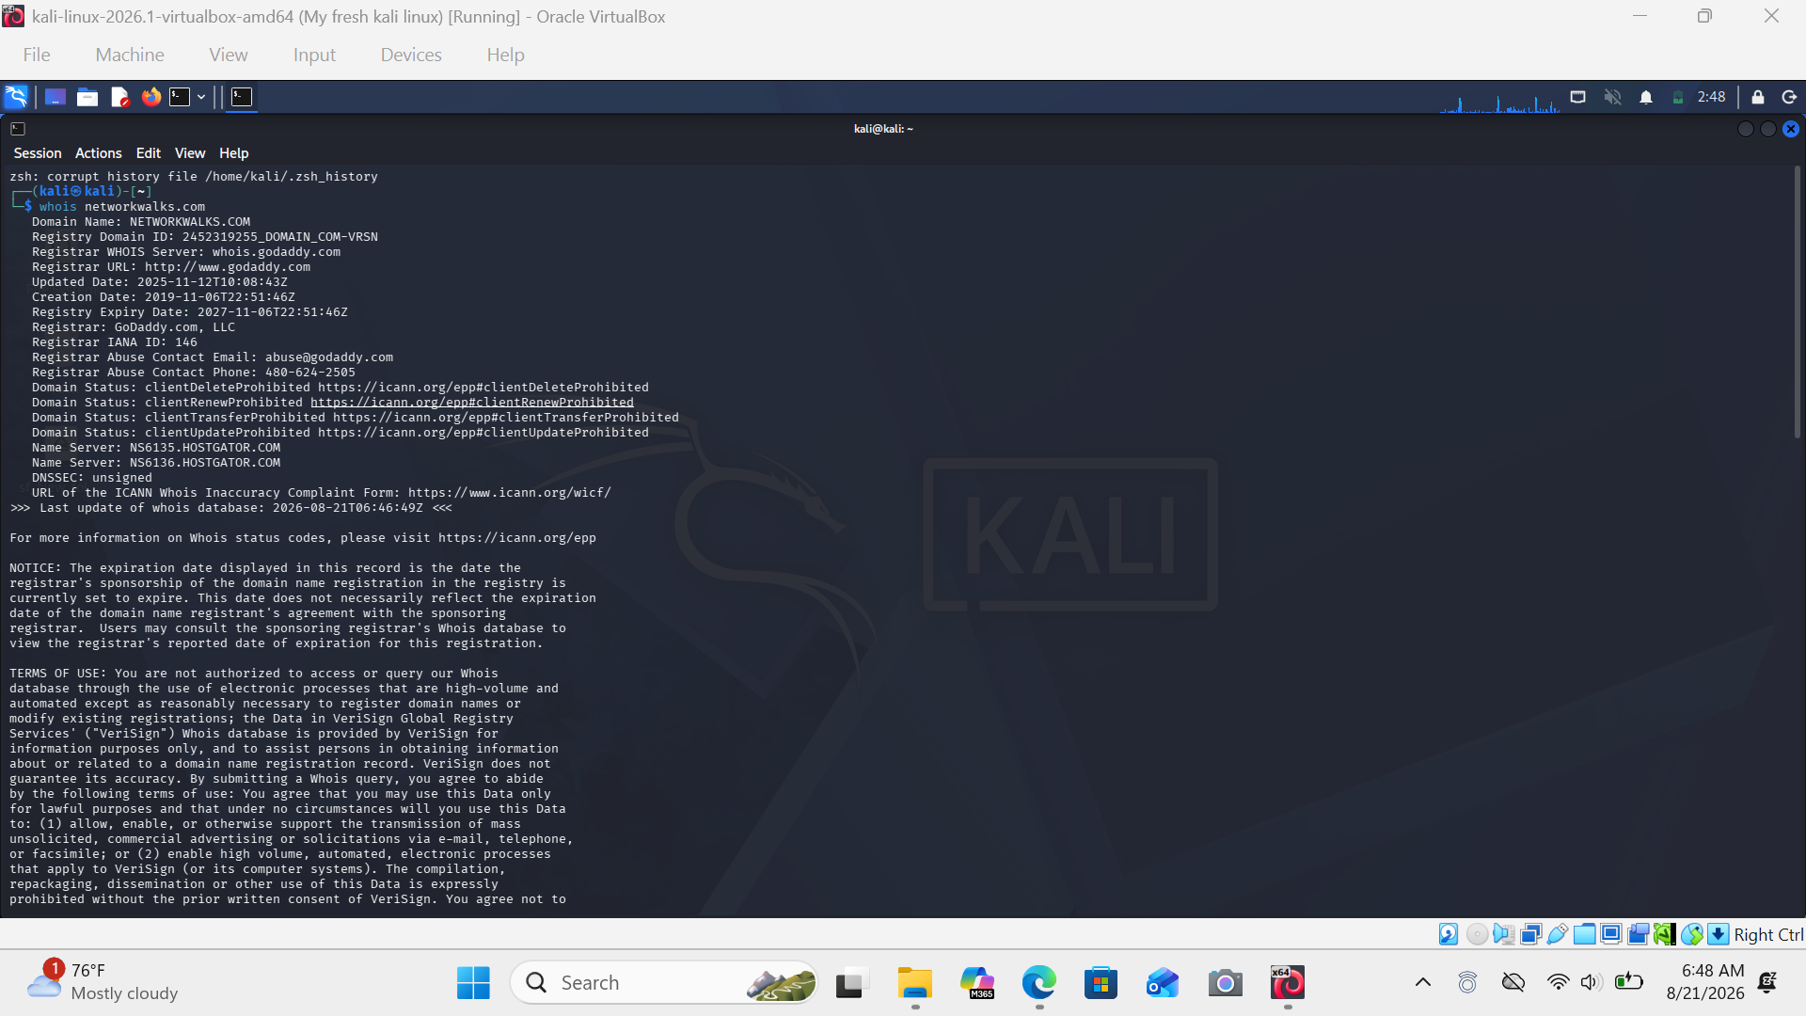
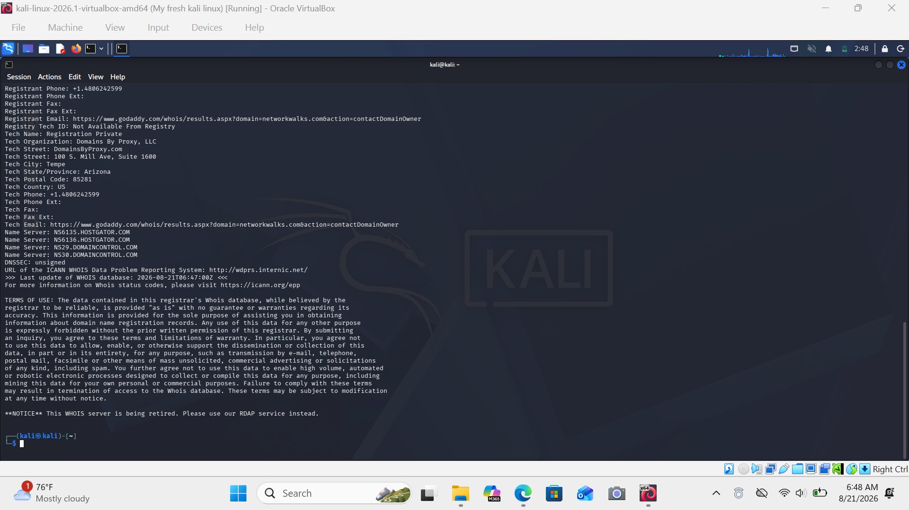

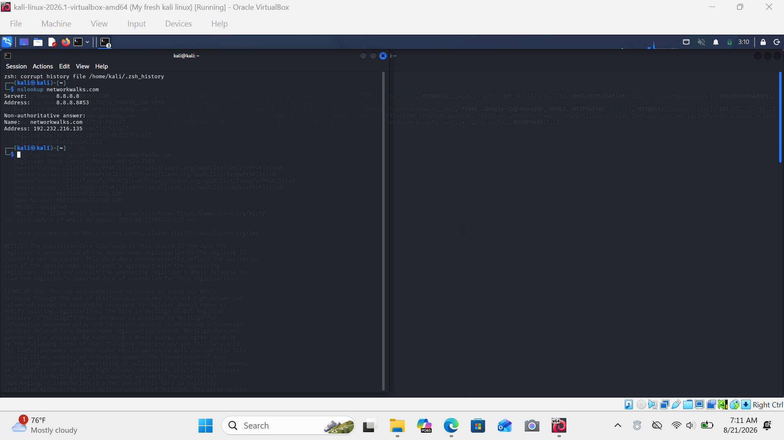
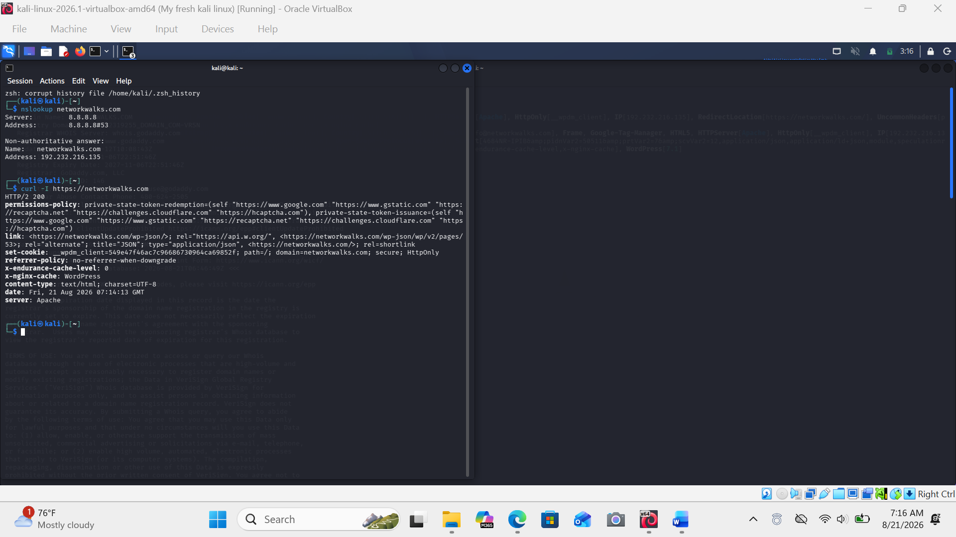
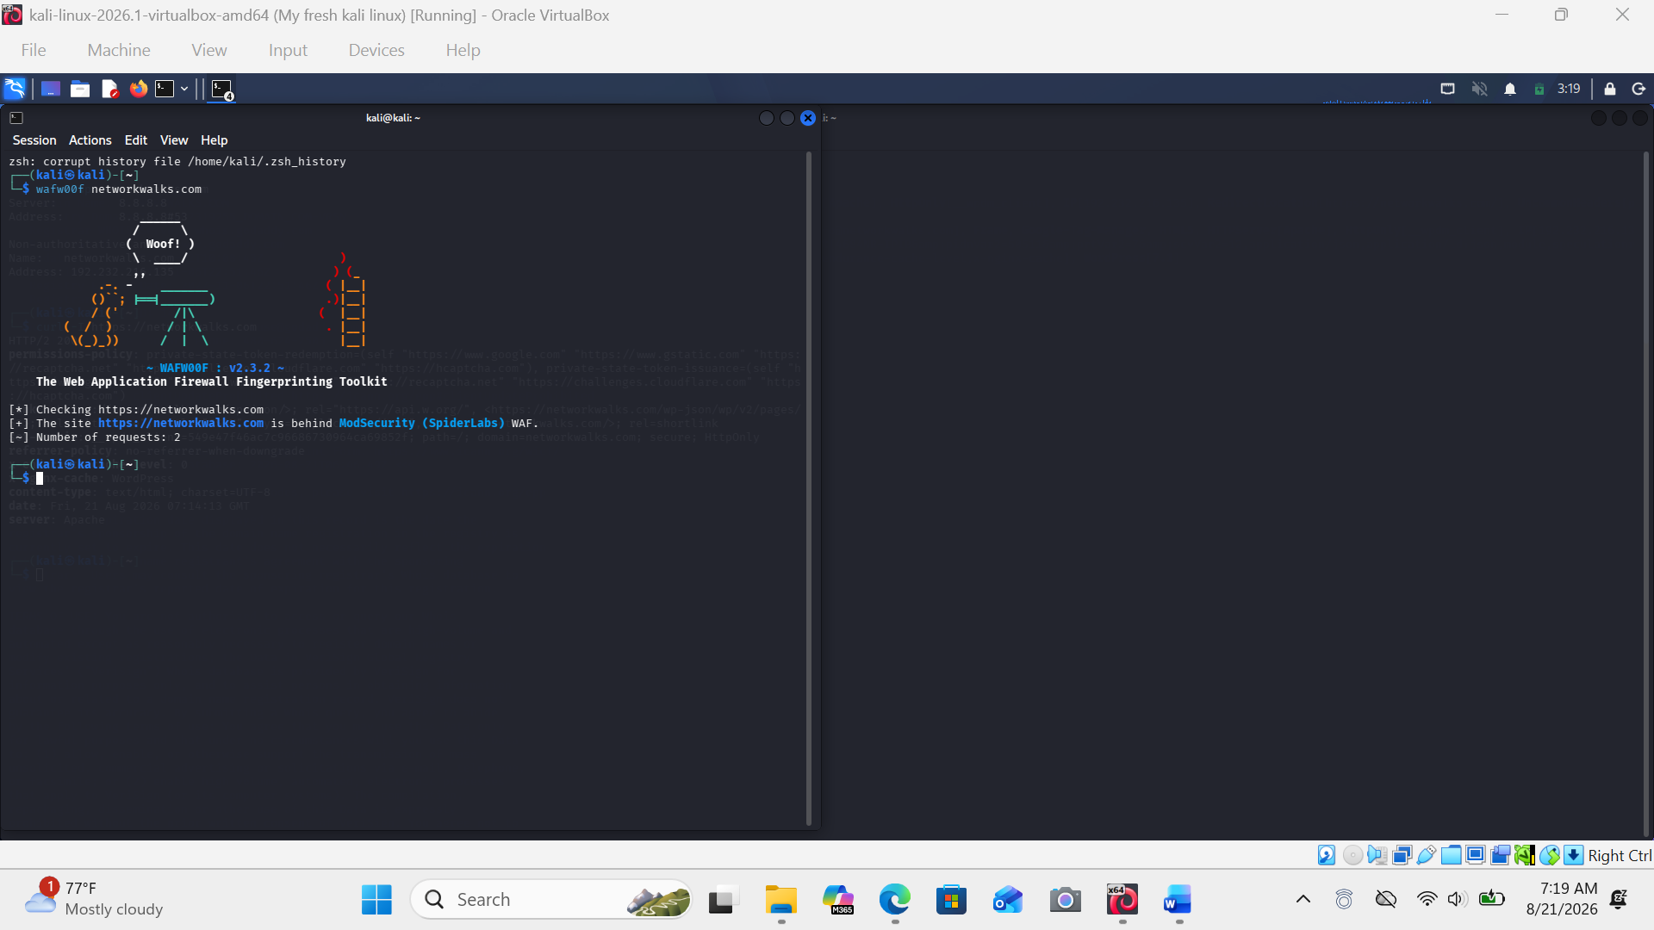
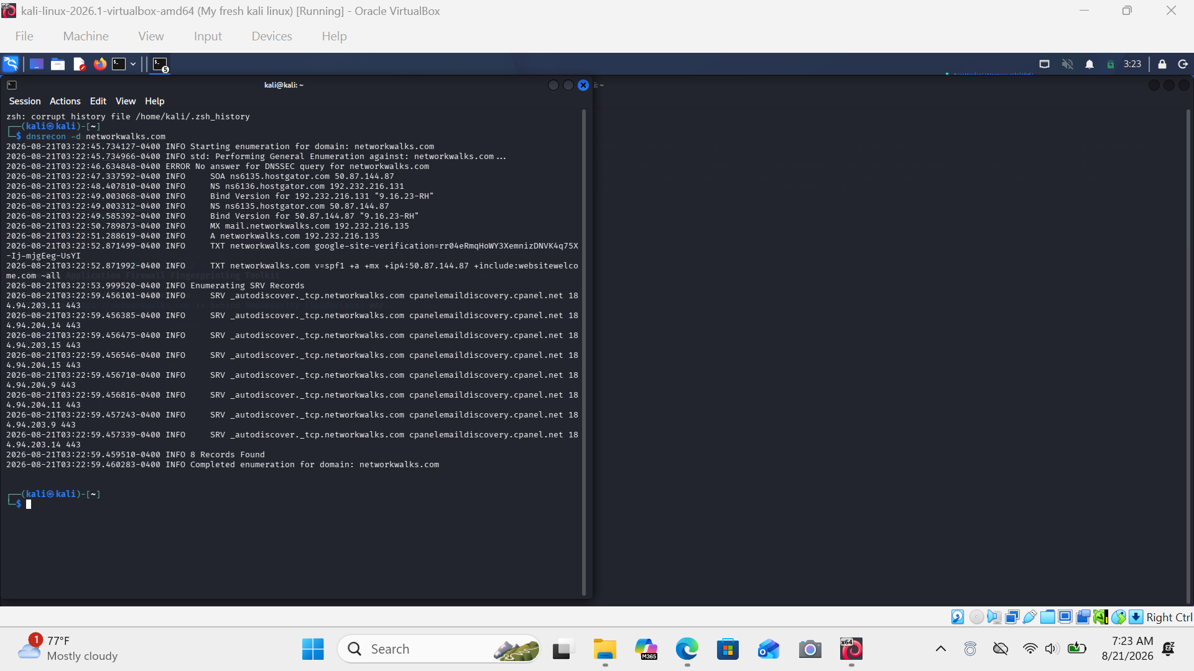

Module W2-PM5 — Network Scanning with Zenmap
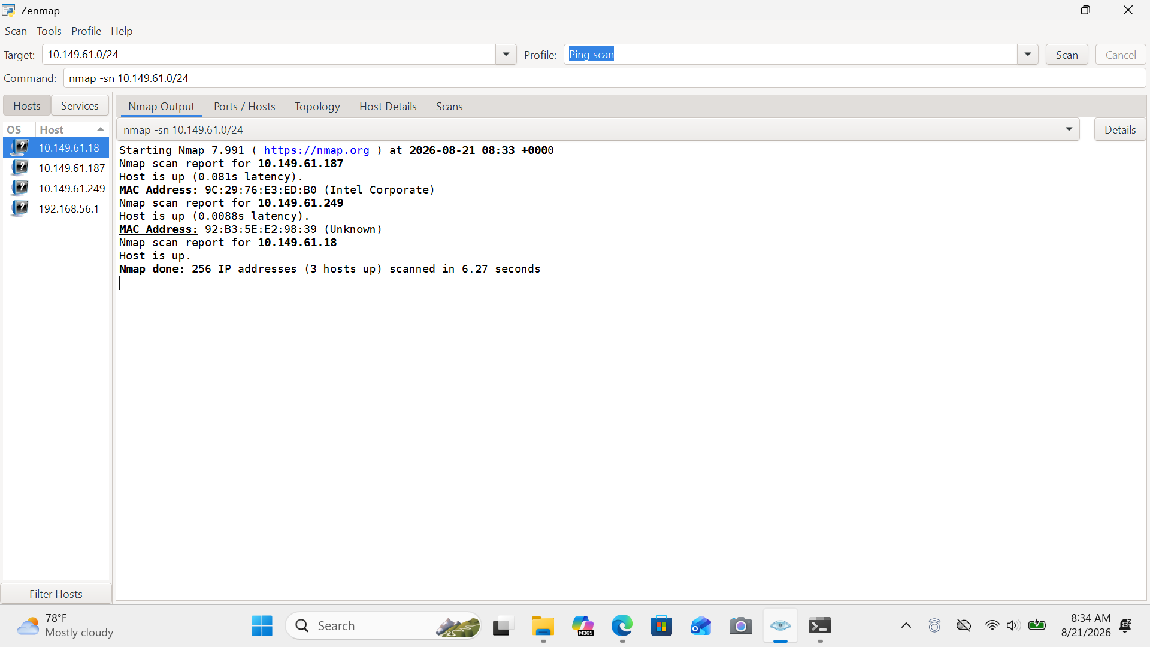
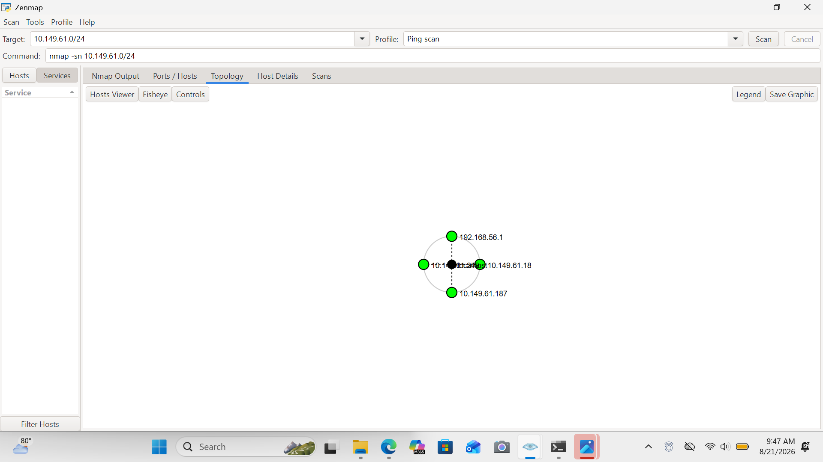

Author
Anaaba Maxwell Apuswini
Cybersecurity Intern B082
www.linkedin.com/in/maxwell-anaaba-1a0886348

